**Requirements Analysis**

|  |  |  |  |
| --- | --- | --- | --- |
|  | **Requirements** | **MoSCoW**  **Prioritization** | **Functional(F)/ Non – Functional (NF)** |
|  | Registration | **M** | **F** |
|  | Login | **M** | **F** |
|  | Dashboard | **S** | **F** |
|  | Mobile information | **M** | **F** |
|  | inventory | **M** | **F** |
|  | Generate and print bill | **M** | **F** |
|  | Purchase information | **M** | **F** |
|  | Data (add, update, delete, view) | **M** | **F** |
|  | Product( add, update, delete, view) | **M** | **F** |
|  | View order Information | **M** | **F** |
|  | Order Online(e-sewa) | **W** | **NF** |
|  | Review | **C** | **NF** |
|  | Discount | **C** | **NF** |
|  | Exchange | **C** | **NF** |
|  | Receive order via Cash on delivery() | **M** | **NF** |
|  | Cart | **M** | **F** |
| 18. | Warranty Form | **M** | **NF** |

**Class Diagram**

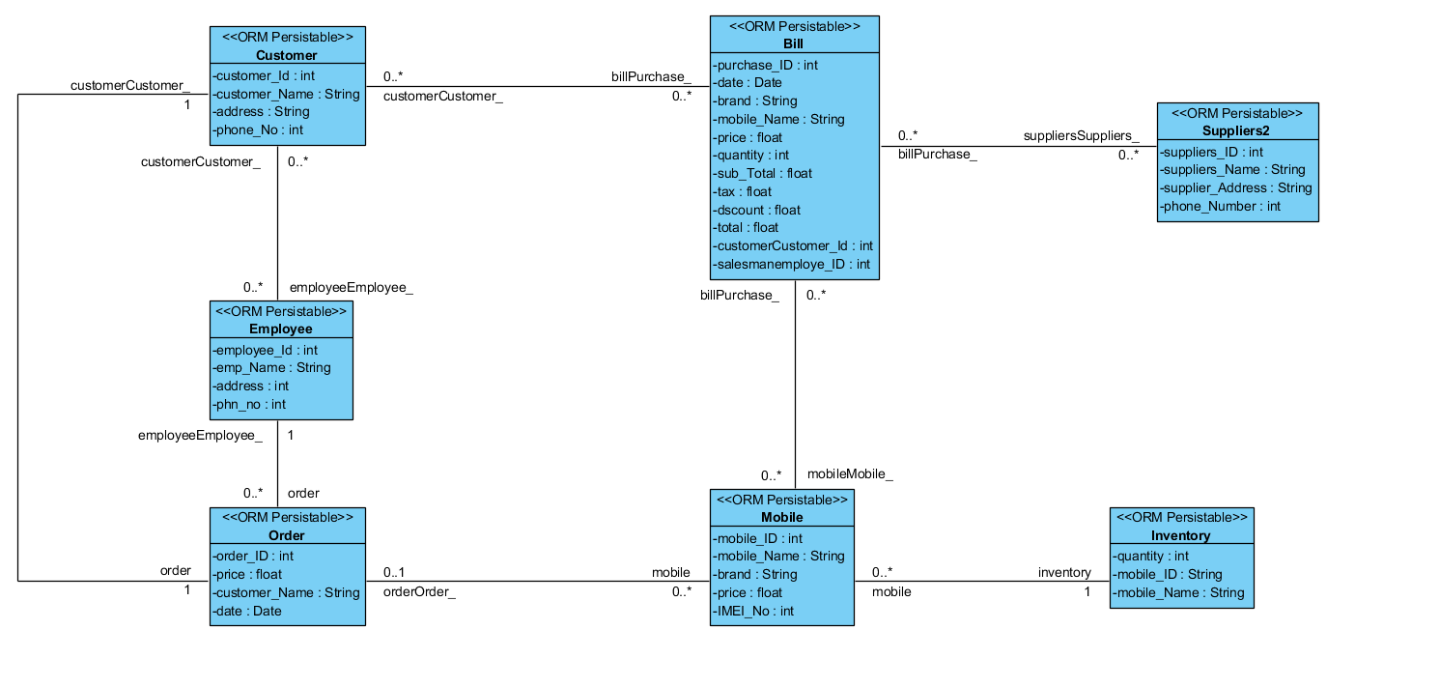

Figure 1: Class Diagram

**ER-Diagram**

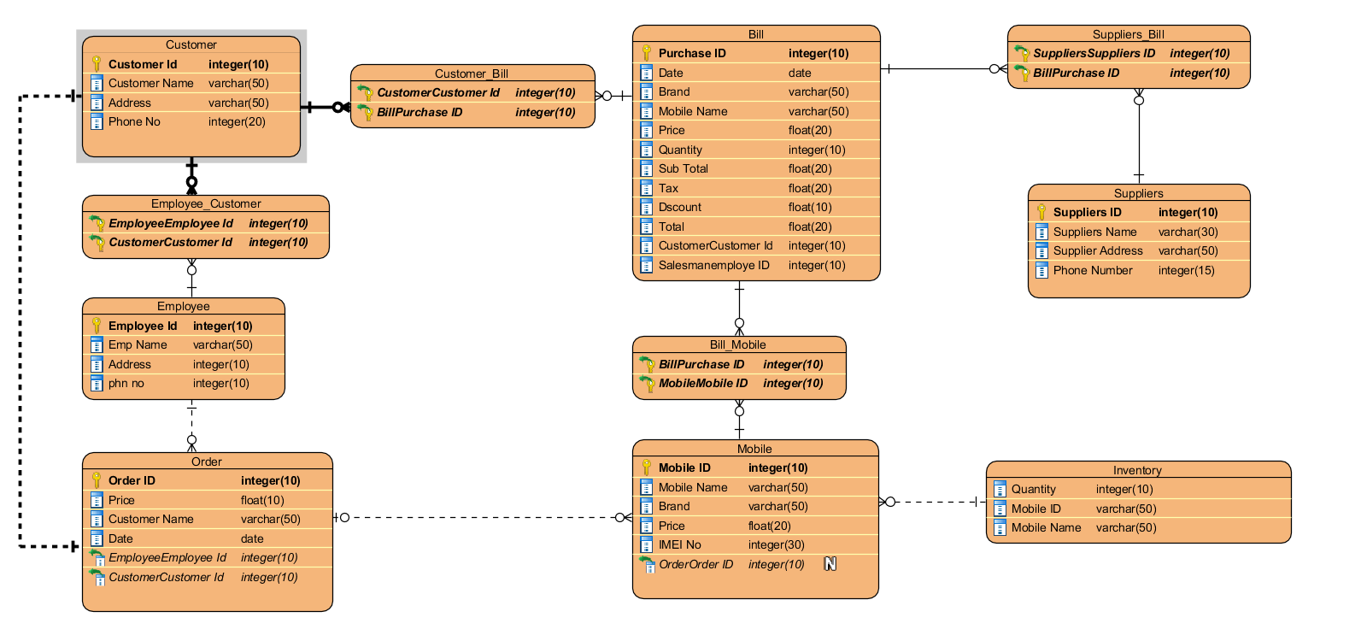

Figure 2: ER-Diagram

**Use Case Diagram**

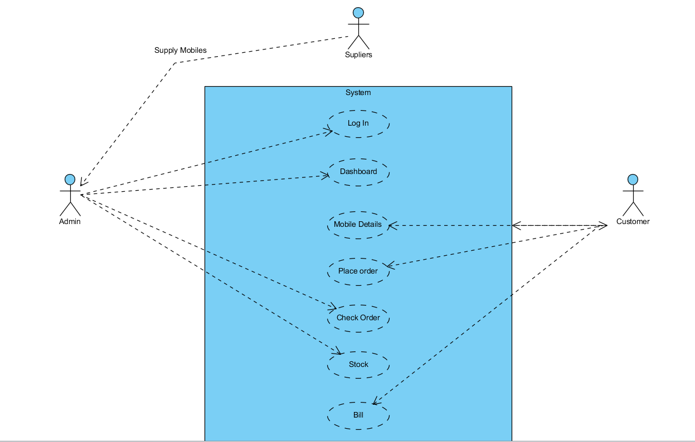

Figure 3: Use Case Diagram

**UI Design**

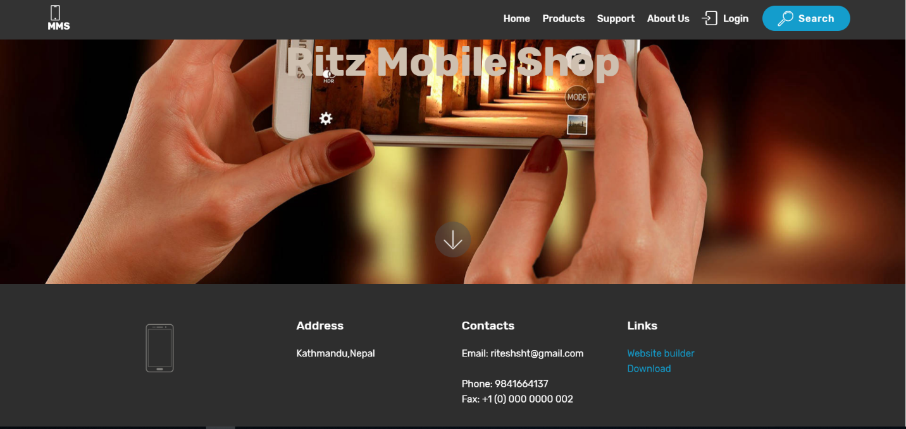

Figure 4: Home Page

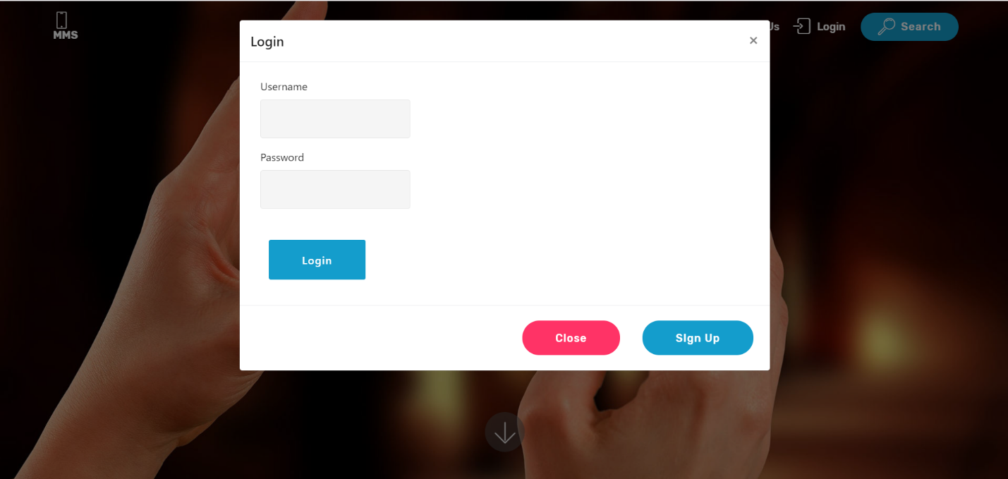

Figure 5:Login Page

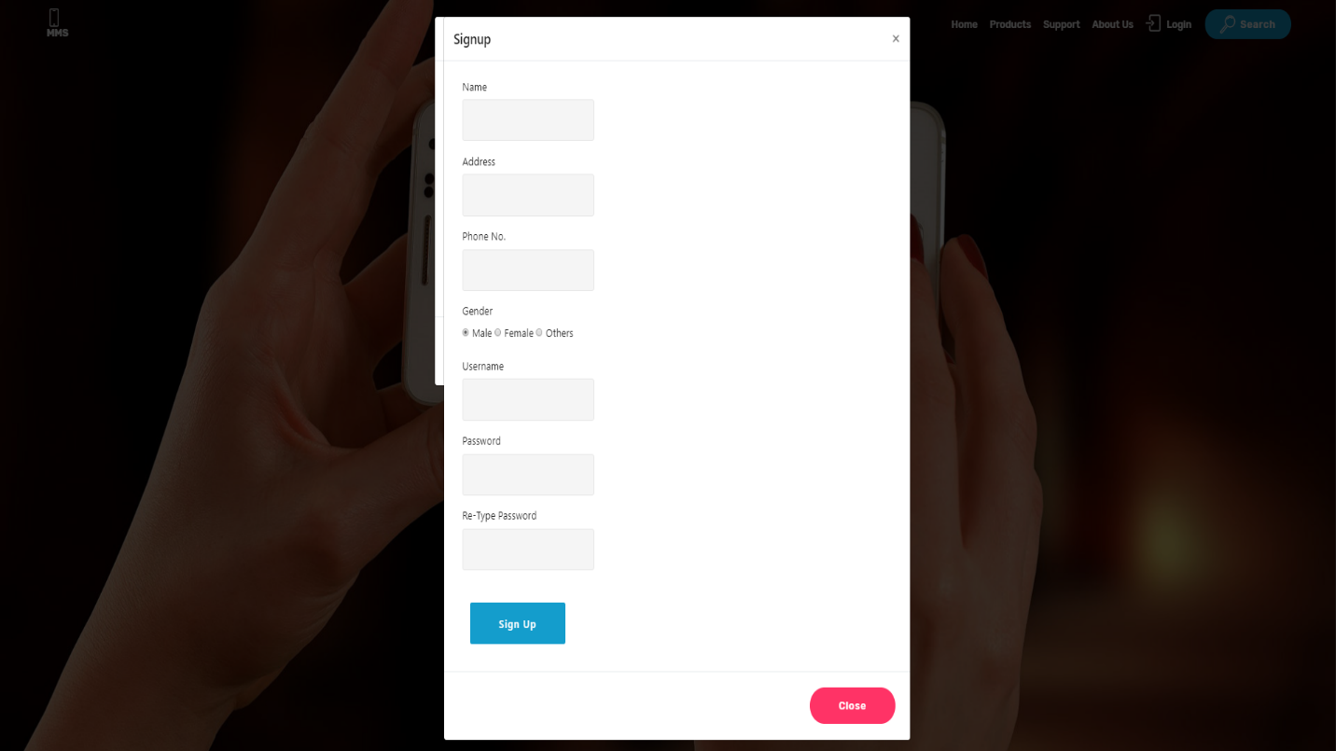

Figure 6: Registration for new User

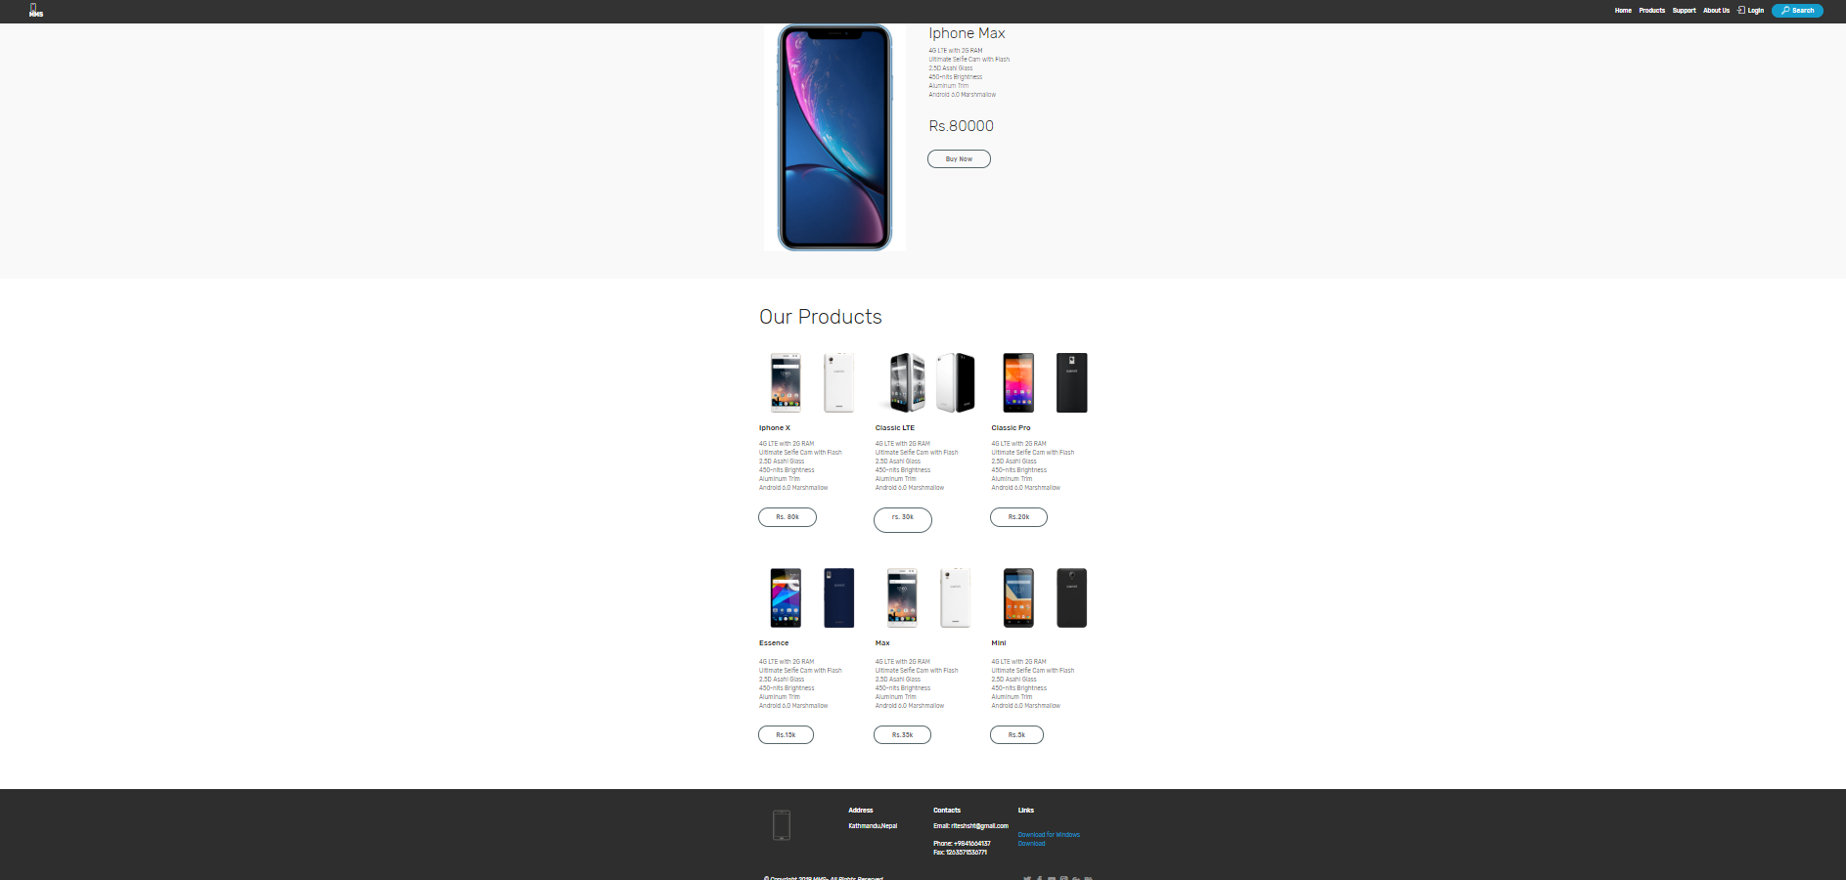

Figure 7: Product Information Page



Figure 8:Footer Page

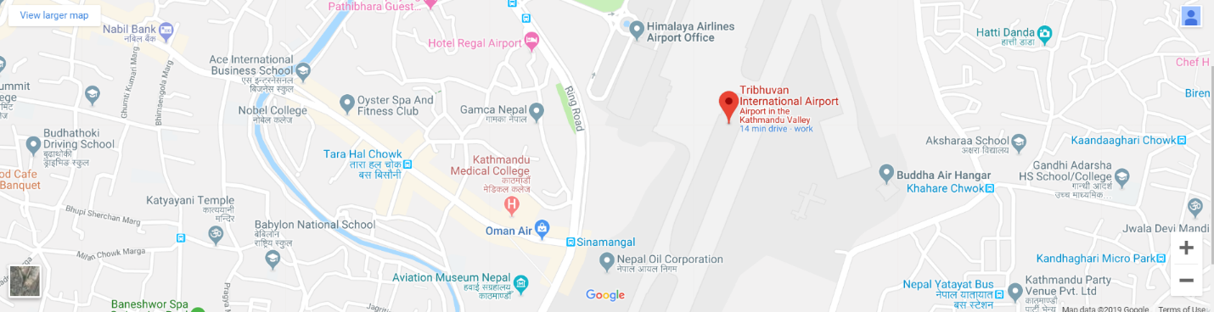

Figure 9: Map page